Newsletter December 2017

What has St Mary’s Secret Garden been up to?

Gardening for the Community
Many of our groups have been busy since the spring in and around our local St Mary’s Estate. We have been working together, with monies secured from the Hackney Council’s tenants levy, to make new feature beds and plant bulbs around the estate. Over 9,000 bulbs were planted in one day – thanks to the help of Bank of America. Keep an eye on the grounds in Spring.
Harvest Festivals Galore!
0De Beauvoir Show - our gardeners entered many categories in this fantastic show –walking away with the award for most points by a club! City Harvest Festival at Capel Manor College, Enfield is where the London gardens and city farms come together to show our work. Our display stand won the coveted MPGA (Metropolitan Gardens Association) award – with prize money of £150. Next year will be the 20th anniversary of the event so will be huge. A pleasure as always to provide a basket of our gardens produce to St Chad’s Church, Father James, the congregation and the night shelter for the homeless. We still have produce available at the garden – please pop in when the gates are open.
Shed Therapy
Every garden needs a shed and our new one is coming in useful when working with the Tavistock and Portman NHS foundation trust. Our shed is providing a safe and unusual environment to host talking therapy sessions followed by some horticultural therapy. This excellent programme could not have begun without the support of you via Tesco’ Bags of Help’ scheme and the Hospital Saturday Fund. We hope the shed sessions will continue.
Fundraising
A HUGE thanks to Asda at Leyton and all their customers – we received a £200 cheque! Another huge thanks to workers of Monsoon who through their fundraising activities have raised a princely sum for the garden.
Coming up!
Christmas is coming and I am sure the city farm geese are getting fat! We have fayres and activities for you. For early Xmas shoppers on Saturday 25th November we will be at De Beauvoir Xmas fayre at the crypt, St Peter’s Church in De Beauvoir. On Sunday 3rd December we will be at The Handmade Winter Fair at Rosemary Works School N1 12-3pm (with Santa!) Look out for the evening of 14th December at the garden – we are having our late night shopping & wreath making event TBC.
0How you can support us
At this time it is increasingly difficult for small charities to keep going we appreciate any help that you can give us. There are many ways including:
- Become a member of the local Co-op and support us through their community scheme and help us share the Secret of Growing
- Donate to us through Local Giving https://localgiving.org/charity/secretgarden/
- Donate to us when shopping on line with ‘Give as you live’ https://www.giveasyoulive.com/
- Pop into the garden and put a few coins in our donation box (or buy some of our plants / chutneys for Xmas)
- Pop into SuperLyan bar in Hoxton – have a cocktail and donate a £1
- Paul Foinette of Hackney Council is running the London Marathon to raise money for us – more info coming.

Gardening Places Available
We have volunteering sessions on a Monday for people over 60 thanks to funding from Team London.
We also have some vacancies on a Wednesday afternoon in our supported volunteering sessions.
Please see our website and contact us for further information.
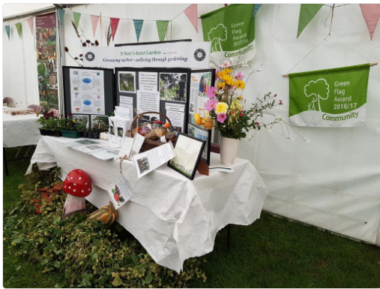
Capel Manor Harvest Festival
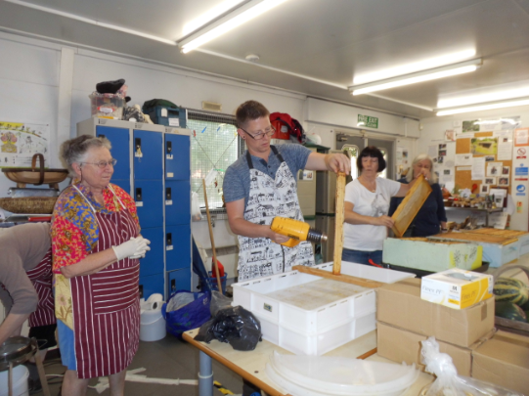
Honey Extraction
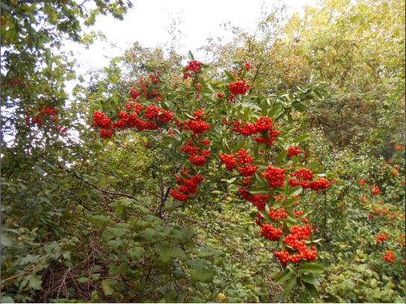 Pyracanthus

