
Secret Garden Newsletter Autumn2010 www.stmaryssecretgarden.org.uk
News
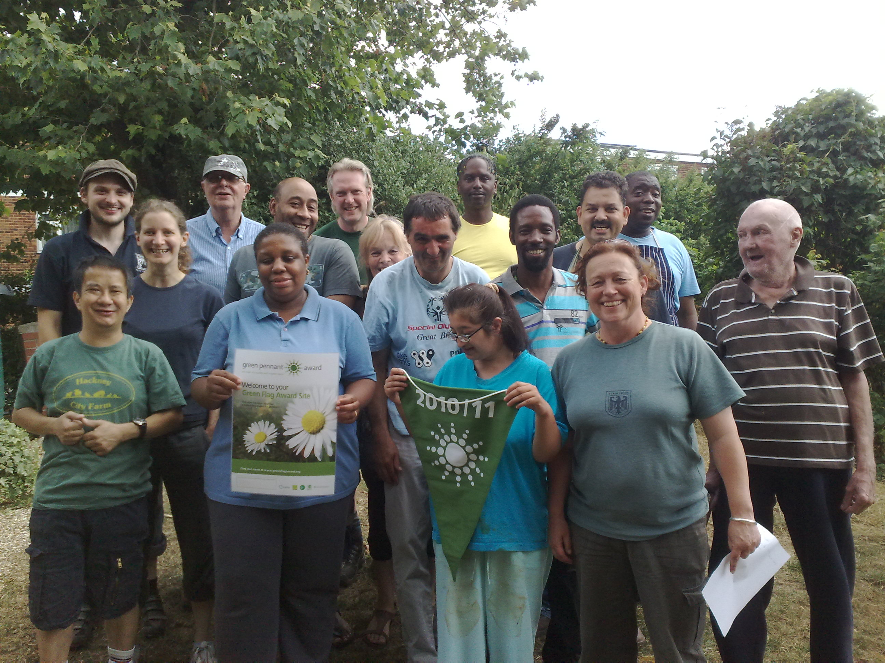
St Mary’s Secret Garden has had a very successful summer! We received a Green Pennant Award, a national award that recognises high quality green spaces, and also won Hackney in Bloom for best voluntary organization. Hurray for us!
PIC

We had our annual Autumn Flower Show when we celebrate the hard work and growing successes of our volunteers. Fortunately the weather was kind, we had a bbq and some delicious food cooked by Shoreditch Spa using produce from the garden, played Frisbee and boules. Prizes were given out for all sorts of categories including heaviest pumpkin which Barry still won despite the theft of his favourite, ‘Mr Big’!

We have received funding from the Big Lottery’s Eco Minds to construct a garden for mental health and well being. We will be working with people who experience mental health distress to redevelop a part of the existing garden and create a garden for them and the wider community to use.

Some of our new Grow More beds are now available to rent at £20 per plot including membership of our key holder scheme. Although the plots are small, they provide an opportunity to grow crops in a beautiful community garden.
We currently have 3 triangular beds, with 2 rectangular beds coming soon. These will have low sides so are suitable for gardening with children.
If you are interested in renting a plot, please contact us at info@stmarysgarden.org.uk or call us on 0207 739 2965
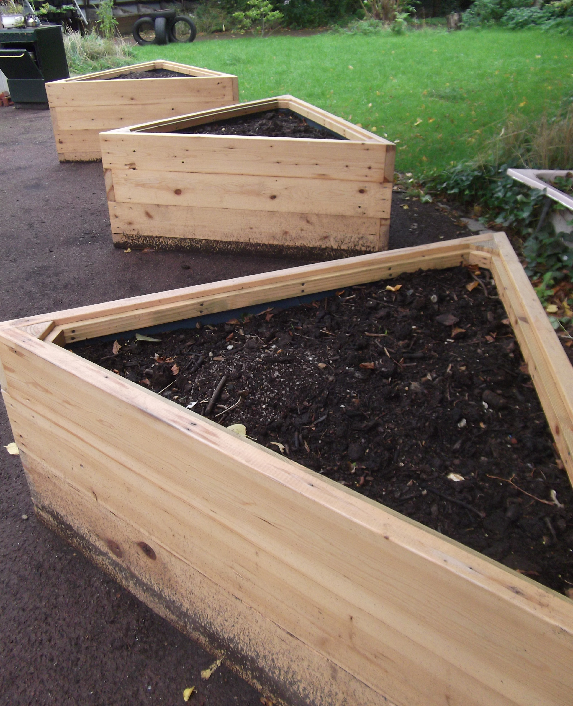

More news….

Paula Gent, our manager and leader, has become a representative on the Learning Disabilities Partnership Board. There will be regular updates in this newsletter on relevant issues, and if you have any issues you would like Paula to bring up with the board, please contact her on info@stmarysgarden.org.uk or by phone on 0207 739 2965

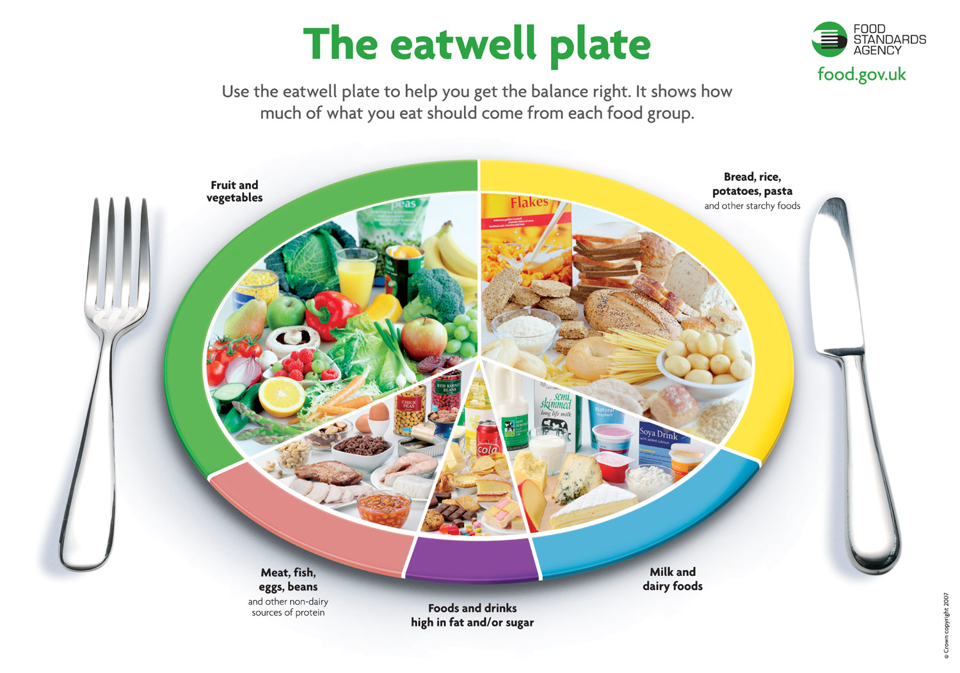
We are a pilot organisation for Healthy Hackney Standards, developed by the Shoreditch Spa, a quality mark awarded to organisations which promote health and well being for children and families.
We are hoping to include healthy seasonal recipes on our website soon.
As part of the standard, organisations are expected to lead by example, so we are trying to ditch the biscuits and say no to fizzy drinks!

Updates
Thanks to all the corporate groups who have been working hard at St Mary’s, including:
- KPMG
- Deutsche Bank
- Citi Bank
We now have a polytunnel, shelving in our tidy sheds and new signs for the garden entrance.
Special thanks to Deutsche Bank for their very generous donation of £3000!

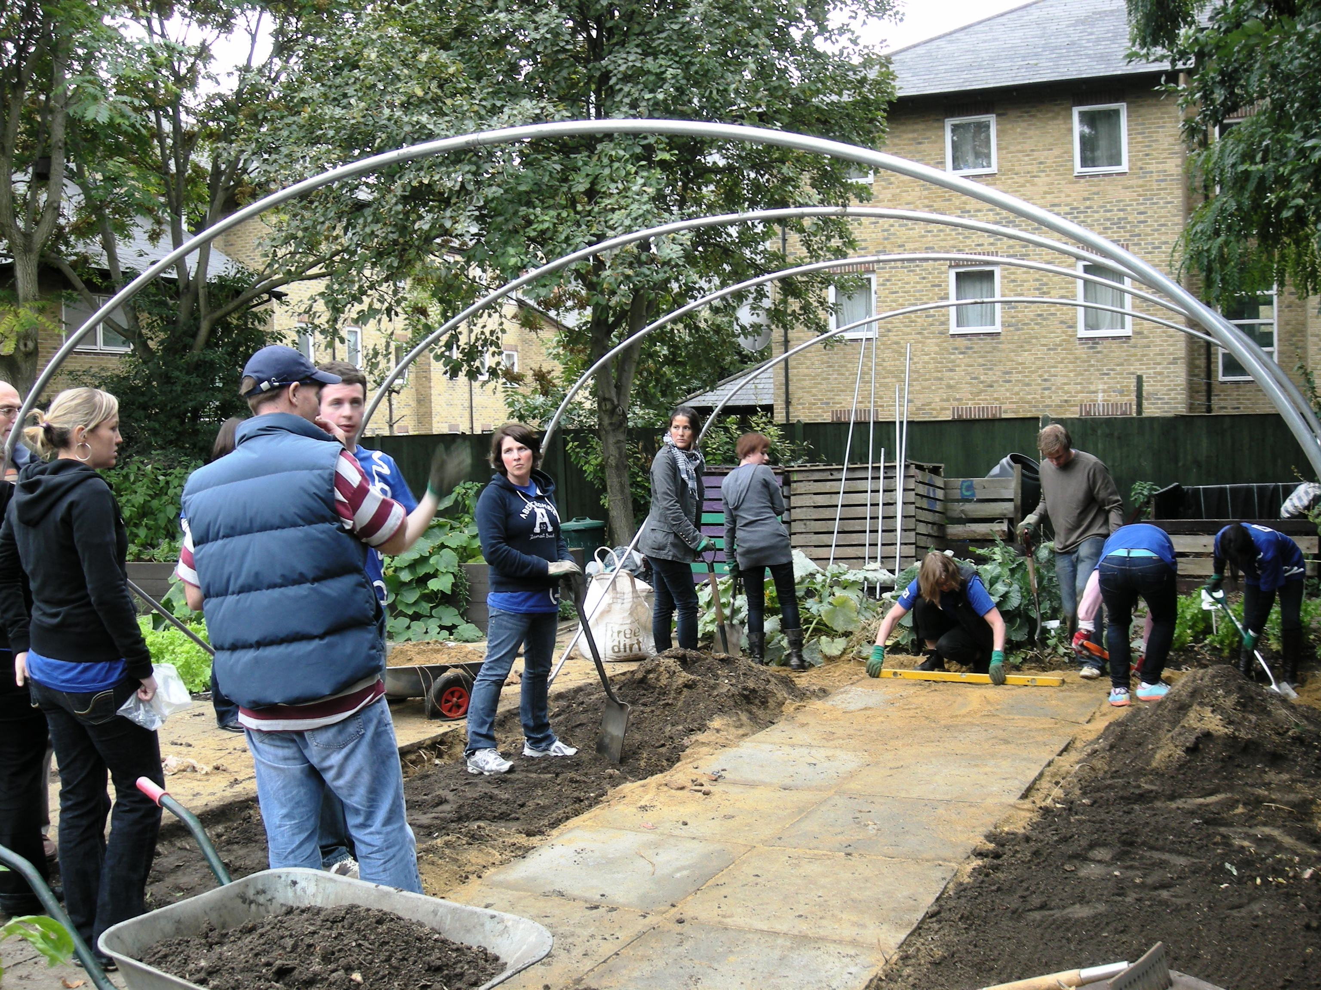

This autumn in the garden…….
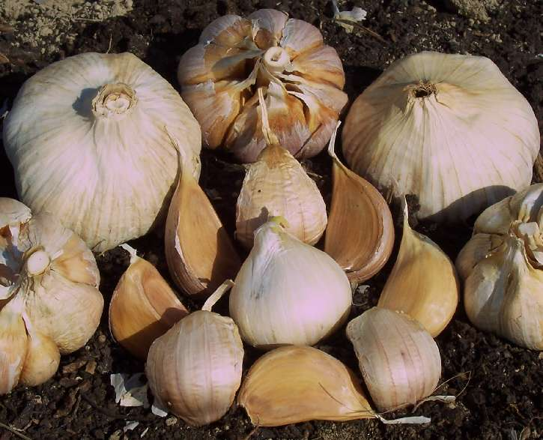
Gardening tips
Now is the time to get onions and garlic off to an early start. Plant sets and individual garlic cloves into prepared soil, with their papery tips poking out just above the surface. But make sure you protect them from thieving birds. Broad beans can also be sown into pots or directly into the ground.

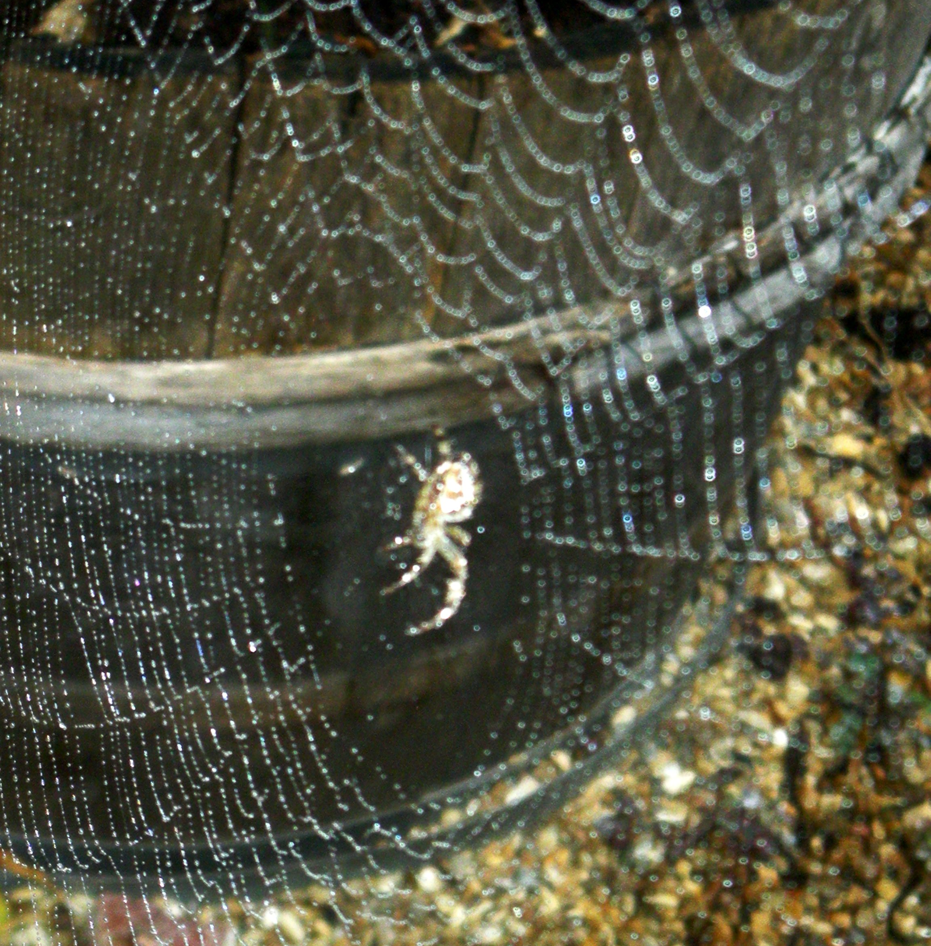
Wildlife watch
We’ve had some amazing ‘September spiders’ in the garden this year. They are orb weavers, and have very strong (and beautiful) spiral webs.

What’s good to buy in the garden
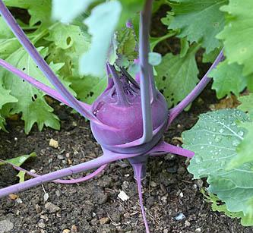
‘Scuse me while I kiss the sky! Everything’s gone a bit Purple Haze this autumn; we have some beautiful purple cabbages for £1, purple kohlrabi soon to be ready, and don’t forget Geranium ‘Purple Haze’ – it’s the perfect time to plant one! Also good to eat and gorgeous to look at is our Rainbow Chard – a bargain at £1 a bunch

The Work Preparation Group have been coming here on a Tuesday, some of them for 6 years. They do a lot of the heavier work around the garden, as well as doing gardening work in the wider community, such as planting up and maintaining the planters at Old Street’s Roadtrip Bar.
‘I love it here because it’s outdoors and it’s a friendly place,’ says Israel, who supports Man U.
Farez, an Arsenal supporter, likes working with Israel, and using his muscles!
‘I like to do sweeping, mowing the lawn and picking fruits and vegetables.’ says Paul. They all work very hard and we appreciate it!

Gardener profile
The work prep group, Farez, Israel and Paul, with our O.T. student Kimberley.



